QR-Attendance Project Documentation
Team: 2
Members:
- Buntha Somavottey
- Din Sovanlysar
- Eng Sei
- Thang Seavvey
- Pich Soksovann
- San Meyching
- Sakun Sreymoch
- Son Sreymoch
- Srun Sovanpanha
Class: PRO101-FECO-D1 & R1
Professor: Dr. May Thu

- Project Overview
This project aims to digitalize the way teachers mark students’ attendance by replacing the manual process of calling students’ names with a quick scanning system and allowing students to enter their ID and name. This ensures that all student attendance data is recorded efficiently, while each device can only be used to scan once per day after attendance has been successfully marked. After the first-time scan, students only need to enter their name, and their ID will be automatically suggested through the ID auto-suggestion feature. This brings greater convenience to both students and educators.
- Problem Statement
Traditional classroom attendance tracking suffers from distinct operational inefficiencies and security vulnerabilities:
- Time Inefficiency: Manual roll calls or passing around physical sign-in sheets consumes valuable lecture time and scales poorly with larger class sizes.
- Data Entry Errors: Hand-written IDs or names frequently result in typos, illegible handwriting, and manual data-entry fatigue for instructors compiling records into spreadsheets.
- Attendance Fraud (Proxy Scanning): Standard static QR code systems allow a single student in the classroom to take a photo of the code and share it with absent classmates via messaging apps, allowing students to falsely mark themselves present from home or outside the campus subnet.

- Solution
Our QR attendance tracking system provides a secure, streamlined digital check-in alternative:
- Automated Roll Call: Instructors project a dynamically updating QR code window. Students scan it, verify their identity, and log themselves present within seconds.
- Registry-Linked Autocomplete: An intelligent, debounced lookup field allows students to start typing their name and automatically binds their verified, locked Student ID from the database roster, eliminating entry errors.
- Anti-Fraud Security Fencing: The platform implements an immediate three-layered security gauntlet to block proxy submissions:
  - Sliding Time Window: Token keys automatically expire after a short duration (60 seconds) to render shared photos useless.
  - Subnet Validation: The server checks client requests against the authorized classroom network routing scheme.
  - Device Cookies: Hashed hardware-bound tokens drop onto client device browsers, intercepting and locking down duplicate submission attempts from the same phone.

- System Architecture & Work Flow

The application splits duties into a Student Input Portal (publicly accessible on the local network) and an Admin/Teacher Dashboard (secured via authentication credentials), communicating over an isolated SQLite database state machine.

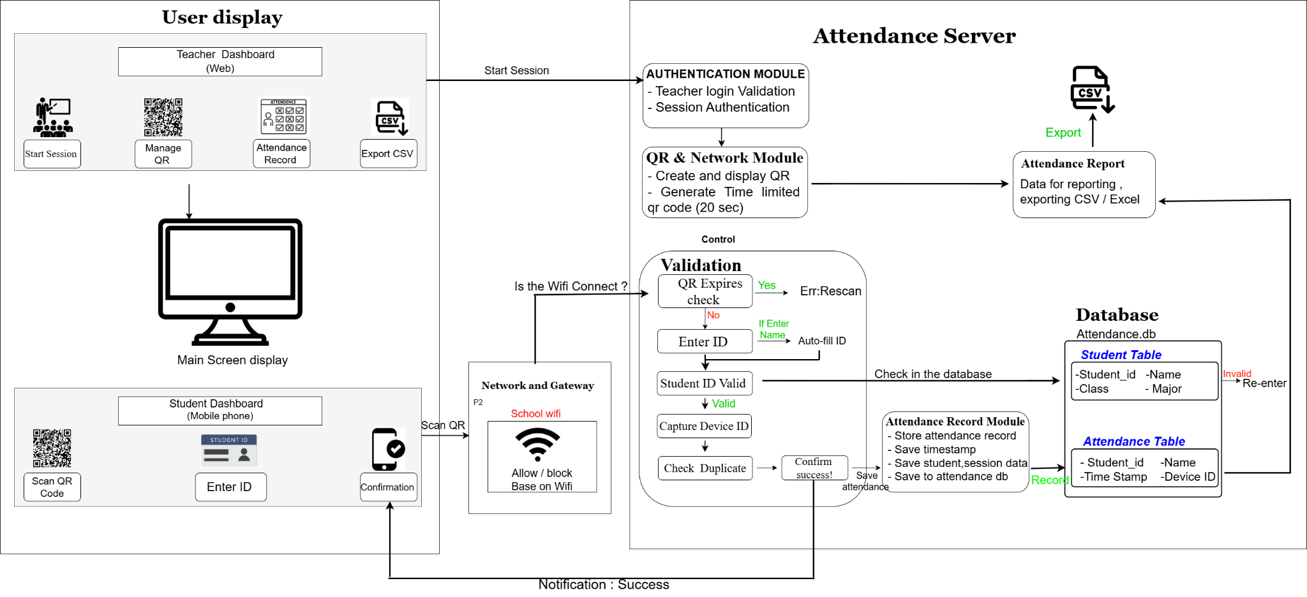

FlowChart :
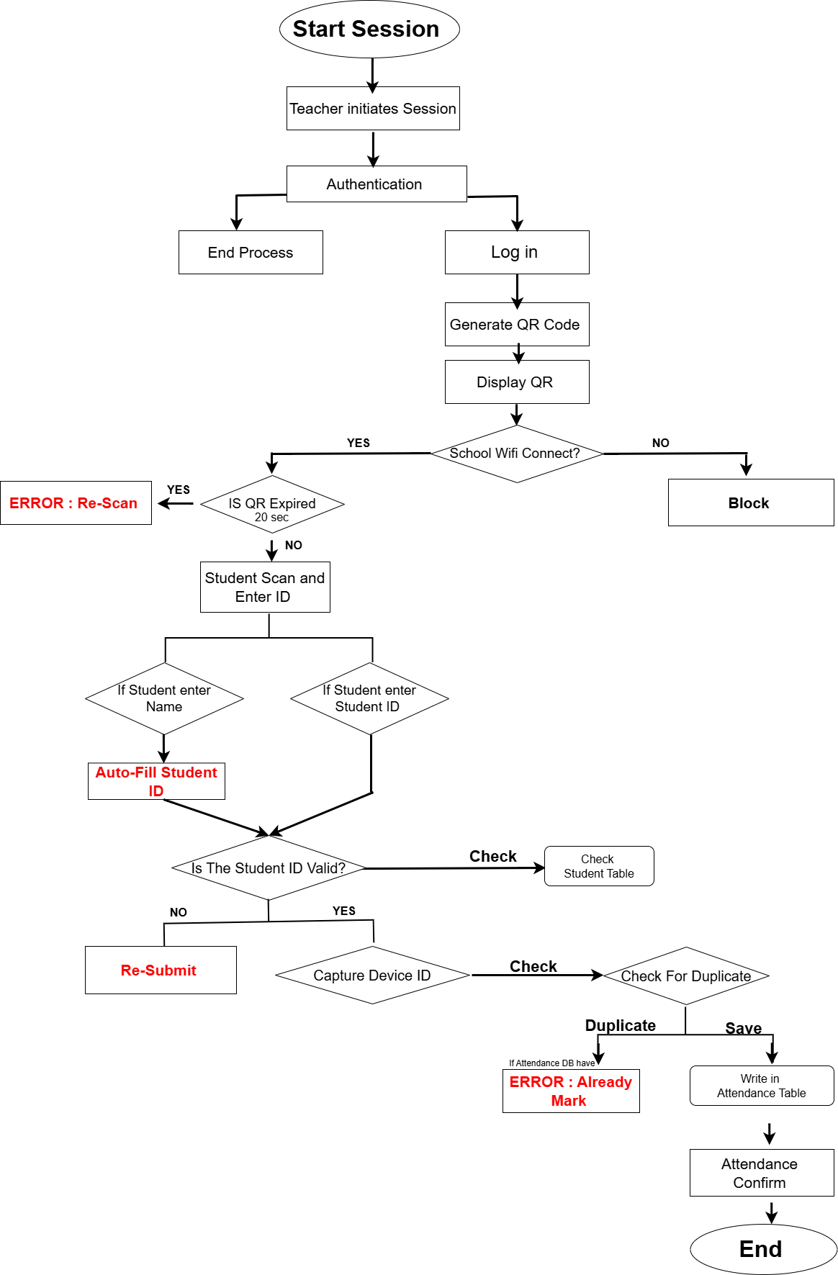

End-to-End Operational Workflow:
- QR Generation: The teacher’s authenticated dashboard interface periodically loops a fresh UNIX timestamp-based token string (/?token=XXXXXXXXX).
- Device Routing Validation: When a student scans the code, the server captures their remote client network address interface.
- Data Lookups: On the submission template webpage, as the user types their name, a background asynchronous endpoint queries the student registry to populate their registered ID string safely.
- Data Transmission: The client submits the completed form using an absolute browser redirection payload, establishing clean data persistence even through highly restricted local mobile browser firewalls.
- Cookie Dropping: The app records the attendance log and saves a tracking cookie payload onto the phone storage, routing them to a locked confirmation dashboard screen to block double entries.
Functional Decomposition

A. Abstraction
System Abstraction Layer | Functional Objective / Business Logic
Secure Tokenized Entry | Students scan a dynamic QR code parameter token to securely bridge into the attendance gateway without exposing a static link.
Network Perimeter Guard | The system automatically validates incoming client device routing boundaries against the physical school Wi-Fi subnet prefix parameters.
Identity Verification Lookups | Provides a smart database autocomplete lookup field that allows students to start typing their name, automatically pulling up and locking their verified Student ID to prevent fraud.
Anti-Tamper Duplication Lock | Enforces hardware-bound browser tracking cookies to immediately intercept and block duplicate attendance tampering from the same phone.
Data Persistence Management | Commits validated student entries down to a persistent local relational database, organizing data by date and time automatically.
Faculty Administrative Interface | Provides an authenticated teacher dashboard console workspace to generate live codes, look up registries, and parse classroom attendance metrics in real time.
Spreadsheet Report Serialization | Streamlines administrative workloads by compiling daily database tables into clean, downloadable CSV spreadsheet files for academic records.

B. Decomposition

1. QR & Network Module
Handles the physical classroom bridge, tracking client source contexts directly at the server socket interface.
- Dynamic Generation: Periodically updates and renders timestamped token vectors on the presenter's interface.
- Time Windows: Enforces a strict 60-second token validity countdown to neutralize stale photos shared via messaging apps.
- IP Capturing: Automatically reads client IP footprints (request.remote_addr) when the mobile camera navigates to the endpoint.
- Subnet Filtering: Compares the client's network address prefix against the authorized 172.16. classroom router parameters.
- Access Boundary: Accepts verified on-site devices while dropping external cellular/home connections with an explicit 403 Network Rejection response.

2. Student Input Module
Manages the user interface interactions on the mobile browser viewport.
- Responsive Layout: Renders a lightweight, responsive interface optimized for small mobile screen dimensions.
- Debounced Search: Runs a 300ms typing debounce delay window to execute smooth asynchronous autocomplete suggestion overlays without crashing the database with queries.
- Sandbox Bypassing: Captures form parameters using an absolute Native HTML Form Browser POST Engine to seamlessly bypass strict mobile browser firewall and CORS sandbox blocks.

3. Validation Module
The logical gatekeeper enforcing data integrity rules before any records are committed to memory.
- Registry Alignment: Matches inputs against the pre-loaded student directory database to immediately reject unregistered user identities.
- Cookie Inspection: Queries system historical states using the has_device_scanned_today() function to check if the phone's tracking signature matches an existing entry.
- Session Restrictions: Restricts system use to exactly one valid entry per student identity profile, per calendar session.

4. Data Persistence Module
Controls structured data read/write transactions securely.
- Relational Database Storage: Maintains long-term data integrity via an embedded relational database state engine using SQLite3 (attendance.db).
- Table Architecture: Organizes logs structurally across two explicit tables (students for the master registry roster and attendance for successful logs).
- Multi-User Queueing: Safely queues overlapping multi-student writes using SQLite's transactional ACID file storage rules to prevent data loss or server crashes.
- Export Buffer: Extracts database structural snapshots into temporary RAM buffers to feed downstream spreadsheet download requests.

5. Notification Core Module
Communicates system status updates directly back to the student or teacher.
- Server-Directed Routing: Natively shifts active page contexts using server-directed templates via Jinja2 engine wrappers.
- Duplication State Rendering: Injects a dedicated visual validation confirmation layout element if cookie checks detect that the student has already checked in.
- Contextual Error Reporting: Dynamically displays descriptive failure text alerts into the HTML layout if token windows timeout, network checks fail, or database unpacking issues occur.

- Tech Stacks
The platform's technology stack is designed to run efficiently on standard consumer computer hardware without needing complex external server infrastructure:
Layer | Technology | Description
Backend Framework | Python 3 / Flask (v3.0.3) | Core application server handling routing, token validation, session management, and HTML template parsing
Database Engine | SQLite3 | Serverless, zero-configuration relational database engine contained entirely within a single localized .db schema file
Frontend UI Layer | HTML5 / CSS3 | Clean, responsive structure and styling adapted for standard mobile viewports and layouts
Frontend Scripting | Vanilla JavaScript (ES6+) | Handles client-side logic, debounce timers, and DOM manipulation for the registry autocomplete dropdown
Data Export Engine | Python csv & io Modules | Native libraries utilized to serialize database logs into clean, downloadable spreadsheet formats
Version Control | Git / GitHub | Used for collaborative source management, backups, and tracking team contributions

- Database Schema Design
The application relies on an underlying relational database engine (attendance.db) using two primary structural tables.

- students
This table acts as the master directory of all registered students in the system. It is queried in real time by the debounced autocomplete search engine on the frontend form.

Column Name | Data Type | Constraints | Description
student_id | TEXT | PRIMARY KEY | Unique academic identifier for the student. Serves as the primary reference key.
name | TEXT | NOT NULL | The student's full legal name is used for registry matching.
class_name | TEXT | None | Class section, batch, or course allocation string metadata.

- attendance
This table dynamically appends a new record every time a student successfully passes the security checks and submits the check-in form.

Column Name | Data Type | Constraints | Description
id | INTEGER | PRIMARY KEY AUTOINCREMENT | Unique incremental transaction index for every single log entry.
student_id | TEXT | FOREIGN KEY REFERENCES students(student_id) | Maps the attendance record directly back to the unique student profile registry.
student_name | TEXT | NOT NULL | A redundancy caching layer string used to display names instantly on the dashboard without demanding slow cross-table SQL joins.
device_id | TEXT | NOT NULL | SHA-256 hashed signature string extracted from browser tracking cookies to detect and block proxy duplication attempts.
timestamp | DATETIME | DEFAULT CURRENT_TIMESTAMP | The exact synchronized server clock value recorded at the millisecond of submission.

- Key Engineering Challenges & Solutions
During development and network configuration testing, two critical bugs were encountered and successfully resolved:

Challenge 1: Local Subnet Context Faults
- Symptom: The Flask application threw critical context binding errors (The requested address is not valid in its context) on startup, crashing instantly.
- Cause: The application host machine had hardcoded network address variables that broke when transitioning from domestic development routers to the campus network environment (192.168.x.x vs. 172.16.x.x).
- Solution: Updated main.py to decouple from hardcoded IP setups, binding execution parameters natively to host address 0.0.0.0. This abstraction forces Flask to listen across all active structural network card interfaces, dynamically routing mobile traffic regardless of the router's architecture.

Challenge 2: Return Type Mismatch and Dict Unpacking Fault
- Symptom: The server crashed during the form submission phase, throwing an internal Python exception: ValueError: too many values to unpack (expected 2).
- Cause: The backend route consumer handler was structurally misaligned with the database access layer. The function record_attendance() was designed to return a single structured dictionary with three keys: success, message, and record. However, routes.py attempted to unpack it inline as a 2-tuple (success, msg = record_attendance(...)). In Python, attempting to unpack a dictionary directly causes iteration over its individual keys, leading to an element count mismatch.
- Solution: Refactored the backend ingestion pipeline in routes.py to handle the dictionary return type natively. The route now captures the singular dictionary wrapper directly as a comprehensive result variable, then explicitly reads the specific parameters via result["success"] and result["message"] keys before running data validation routines.

- Deployment Execution Step (How to run the program)
- Navigate to project root folder: cd D:/attendance_v1
- Initialize and download framework dependencies: pip install -r requirements.txt
- Boot up the backend local web server engine: python main.py
- Open an administrative browser tab to launch the instructor environment: http://172.16.104.112:5000/login

